Renju lesson on November 16, 2000

Hello all!
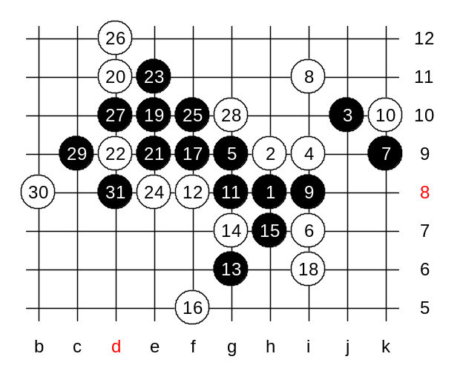
We can begin the lesson. We will continue with the last week topic. Move 5-g9 is considered to be the strongest 5th move, and I have mentioned it several times before, too. Now we take a look at defensive 8th move - i11. The 9-i8, a logical move. There are only two 10th moves possible. I bet everyone can guess them right. Ok, Lu wanted to try k10, lets try it. Let's look together now, where is black's win. I will show you the win. Please remember the idea, it might be useful in many similar positions. In such pattern, usually the move 17-f9 wins. Where should white block that three? If white blocks it at e10 then black wins easily by i6 and h5 which gives two 4x3 threats. Therefore white plays to i6. Now, black has already taken care of white's vertical line, and with next moves black eliminates the last white's open pair. Now, no matter how white defends, black wins. The best defense is d9. Any other white move loses fast. If e11, then black wins with d9, e8, g10, g12 (4x3). If e8, then f10 and black will have simple 2-3 move wins. So, we play d9 as it is the strongest defense. Now, does anyone of you already see black win? Yeah, actually both e8 and e11 give black win. OK, we show e11 win here. If white blocks at e12 then black plays g10 and will have two 4x3 points. Therefore white must play to e8 instead.

Now, speaking of correct choices for the 10th move...
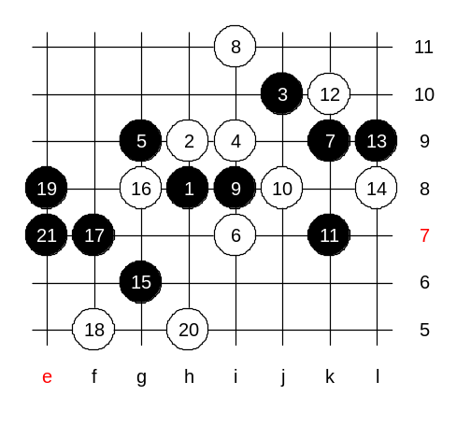
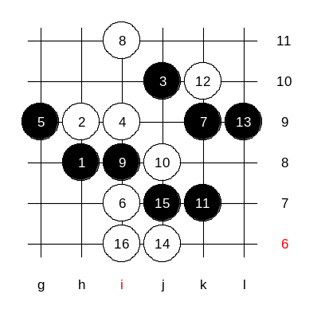
those who guessed g8 and j8, they are right. We try j8 first. As you can see, black has two promising areas for development. Therefore, white will try to play actively - k10. I explain the idea of that move. It blocks the right side directly, and it also controls the left side in very special way. How does it help to block the left side? Well, to understand that we need to look at black's possible development on the left side. Normally black would play to g6 here, considering that white will play g8 and then black f7. But if we think of possible white stone at g8, then we realize that if black plays f7 (or any other move on the lower side), then white can win the game by playing to j11 with having a VCF threat. Briefly: if black g6, white g8, black f7, then white plays j11 and has a VCF threat. Do you see that white VCF threat after j11 in case white has a stone at g8? In renju game, a complicated black attack requires good skill of tactics. Black has some material on the right side, but not ENOUGH for win. Black has some material on the left side, but no TIME to attack. in such situation, black has an excellent solution: Black sacrifies the right side material for defending that possible white VCF threat at j11, and then black has free road for left side development. Move L9 blocks that future white VCF. Do you understand it? It is important to consider the timing - the best timing for defense is to block the possible VCF threat while its not even there yet. Black plays L9 (and NOT to j11) because L9 helps to keep the black tempo - white is forced to defend on the right side. That is what I meant with "sacrifying the right side" - white can defend the right side. Now, black can happily develop on the left side without fear of possible counter-attacks. Now, j11 point is useless, because it doesnt create VCF threat because of L7 stone. Therefore, black could play f7 here without worries. Now, no matter how white defends, black can win easily. Of course, we may test some defense moves here if you wish. Just choose one. Alright, we try f5. Here I have found at least two ways for black win - beginning with e8 or h5, which one do you prefer? White blocks black three from the bottom in order to create some material for counter-attack. If black plays a careless move then white can win g5. However, if we take a close look to the possible beginning of white's counter-attack, then we realize that It can only begin through g5 which makes it possible to control it by black. Black's move e7 controls white g5-attack, do you see it? Black wins.

I will give the homework now. We will have two different homework positions. The medium level homework: Find the black win here. I believe it is more difficult than last week homework.

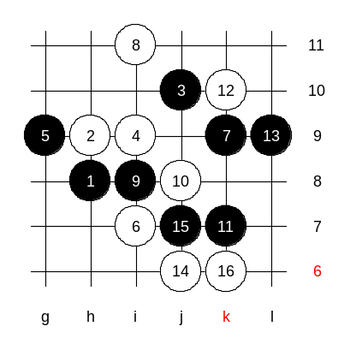
This is the advanced level homework. Please find the black win.
The lesson is over, thank you all for coming and participating. See you again next Thursday.

